FORM 501
(See rule 60(1))

Application for refund under section 51of the Maharashtra Value Added Tax Act, 2002

To

Sub: - Application for refund under section 51 of the
Maharashtra Value Added Tax Act, 2002
Sir,

I /We, the undersigned, has / have filed return / revised return / fresh return in which refund has been claimed by me / us. The details are as under:

Category of the dealer claiming refund |  |  |  |  | (Please tick one or more appropriate box)
Exporter |  |  | Unit | Dealer |  | PSI unit |  | Dealer | Newly
 |  |  | Specified in | making |  | holding |  | claiming | registered
 |  |  | the | interstate |  | Entitlement |  | refund in | dealer
 |  |  | Explanation | sale |  | Certificate` |  | last return | claiming
 |  |  | to sub- |  |  |  |  | of the | refund at
 |  |  | section (3) |  |  |  |  | financial | the end of
 |  |  | of section 8 |  |  |  |  | year | second
 |  |  |  |  |  |  |  |  | financial
 |  |  |  |  |  |  |  |  | year
1 | Name of the dealer
2 | MVAT - TIN
3 | CST TIN

4 Entitlement Certificate No., if any

- Certificate No. issued by JCST in respect of
dealers covered under sub-section (3) of
section 8, if any
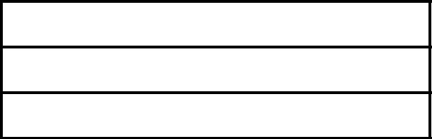
- Address of place of business

- Details of Bank Account in which refund
sought

  - Name of Bank

  - Branch :-

  - Account Number :-

- Period of the return in respect of which
refund is claimed

- Nature of return filed (Regular / Revised
/ Fresh)
10 Date of filing of return

11 | Amount of refund claimed as per this
 | application
12 | Amount of refund claimed so far during the
12 | Amount of refund claimed so far during the | Period | Amount
 | year
13. | Tax paid /Refund claimed during the
13. | Tax paid /Refund claimed during the | Payment | Refund
 | previous year(VAT+ CST)
14. | Whether willing to furnish Bank guarantee
14. | Whether willing to furnish Bank guarantee | Yes/No

- Name and designation with whom contact is
to be made with Phone and Mobile No,

I / We, hereby declare that I/we is/are a dealer holding certificate of Entitlement
under Package Scheme of Intensive and the amount of refund claimed in accordance
with Rule79.

The particulars given above and in the statement of purchases annexed hereto are
true to the best of my knowledge and belief.

I / We, are ready to comply with the necessary requirements.
You are requested to grant the refund in my/our case.

Thanking You

 | Yours faithfully
úDate: | Signature
Place: | Name of the dealer
e-mail id: | Designation and
 | Status
Fax No.:

Annexure to Application for refund in Form 501

Sr. | Name of the | R.C No under MVAT Act | Details of purchases
No. | supplier | of the supplier | Tax Invoice No/Date
 |  |  | Net | Tax | Total
Note.- (1) This statement should include details of purchases made from dealers
registered under the MVAT Act, 2002.

(2) The statement should be prepared party wise, bill wise and date wise and
should include all the purchases made from the supplier, which are credited to his
account in financial records. If it is not possible to prepare a bill wise list in the
printed form, then a soft copy should be submitted.

